H.T No
Regulations:
A15


Sreenidhi Institute of Science and Technology
(An Autonomous Institution)
Code No: 5A714 Date: 11-May-2019 (AN)

B.Tech IV-Year I-Semester External Examination, May-2019 (Supplementary)
Power System Analysis and Control (EEE)

Time: 3 Hours Max.Marks:75

Note: a) No additional answer sheets will be provided.
b) All sub-parts of a question must be answered at one place only, otherwise it will not be valued.
c) Missing data can be assumed suitably.

Part - A Max.Marks:25

Answer all QUESTIONS.

1. | Discuss the ways of adding impedance to an existing system to modify Z_{bus} matrix? | [3M]
2. | Show that real power depends on frequency and independent of reactive power. | [3M]
3. | What is the function of PI controller in LFC system? | [3M]
4. | Describe the classification of buses. | [3M]
5. | What are the essential factors affecting the stability? | [3M]
6. | Define the incremental fuel and production costs. | [2M]
7. | Define the concept control area. | [2M]
8. | Write the advantages of Newton Raphson method. | [2M]
9. | What is the need of optimal scheduling of hydrothermal system? | [2M]
10. | Define synchronizing power coefficient. What is its significance? | [2M]
Part – B Max.Marks:50
ANSWER ANY FIVE QUESTIONS. EACH QUESTION CARRIES 10 MARKS.

11. | a) | Define the following terms with suitable examples.  i)Graph ii) Tree iii) Co-Tree iv) Cut-set matrix v) Basic cut-set | [5M]
 | b) | For the system shown below, Obtain Y_{bus} by direct inspection method. Take bus (1) as reference. The element impedances are indicated in p.u.  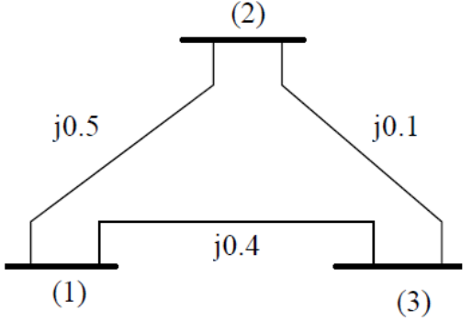 | [5M]
12. | a) | Explain the functional operation of speed governing system with neat sketch. | [5M]
 | b) | A 100 MW unit with 0.05 p.u turbine regulation operates in parallel with a 500 MW unit of identical turbine regulation for a specific amount of power demand increase. Find the ratio of sharing of the load by the units if the system frequency is 50Hz. | [5M]
13. |  | Draw the block diagram for a two-area Load Frequency Control with integral controller blocks and explain each block. | [10M]
14. | a) | Derive general expression for static power flow equations for ‘n’ number buses. | [4M]
 | b) | Compare Gauss-Seidel, Newton Raphson, Decoupled and Fast decoupled methods with respect to  i) Number of iterations ii) Convergence characteristics iii) Initial values | [6M]
15. | a) | Explain the terms i)Transient stability ii)Dynamic stability | [5M]
 | b) | A 200 MVA, 2 pole, 50 Hz alternator has a moment of inertia of 50000 Kg-m². What is the energy stored in the rotor at the rated speed? Find the value of H and determine the corresponding angular momentum. | [5M]
16. | a) | Obtain the economic operation schedule for three thermal units delivering a total load of 750 MW by considering with and without generator limits.  Unit1: P_{max}=600 MW P_{min}=150 MW, F₁(P₁) = 570 + 7.5P₁ + 0.0017P₁² Rs/hr  Unit2: P_{max}=500 MW P_{min}=125 MW, F₂(P₂) = 380 + 7.8P₂ + 0.002P₂² Rs/hr  Unit3: P_{max}=500 MW P_{min}=125 MW, F₃(P₃) = 200 + 7.9P₃ + 0.005P₃² Rs/hr | [6M]
 | b) | Give various uses of general loss formula and state the assumptions made for calculating B_{mn} coefficients. | [4M]
17. | a) | What is fundamental cut-set? Obtain cut-set matrix for the following graph.  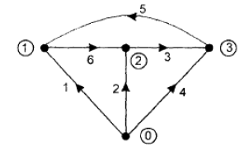 | [4M]
 | b) | Two generators of rating 125 and 250MW are operated with droop characteristics of 4% and 5% respectively from no load to full load. Find the load sharing by each generator if a load of 300MW is connected across the parallel combination of those generators. | [3M]
 | c) | Draw the block diagram of load frequency control and economic dispatch control. | [3M]
18. | a) | What are the assumptions in static load flow equations and derive the approximate load flow equations. | [4M]
 | b) | List out the various applications of Equal are criterion. | [3M]
 | c) | Sketch the heat rate curve and cost curve of thermal power plants and explain the significance of them. | [3M]
-- 00 -- 00 –

